Jacaranda Science Quest 10: Topic 7 test 1

Topic 7 Global systems Name: ___________________________

 | Identify an abiotic component of the natural environment.  - Competitors  - Wind speed  - Predators  - Plants |  | 1
 | Identify a biotic component of the natural environment.  - Shelter  - Humidity  - Salinity  - pH |  | 1
 | The process used by plants to convert energy from the sun into chemical energy is:  - diffusion.  - respiration.  - photosynthesis.  - transpiration. |  | 1
 | The breakdown of the remains of dead organisms on and below the Earth’s surface is largely the responsibility of:  - consumers.  - decomposers.  - producers.  - scavengers. |  | 1
 | Plants return water from the soil to the atmosphere in the process of:  - respiration.  - photosynthesis.  - transpiration.  - decomposition. |  | 1
 | Which of the following is not involved in the carbon cycle?  - The burning of fossil fuels  - The process of respiration  - The process of transpiration  - The formation of fossil fuels  - The formation of coral reefs |  | 1
 | Which of the following properties of freshwater can be described as a physical property?  - Dissolved oxygen  - pH  - Nitrate level  - Temperature  - All of the above  - None of the above |  | 1
 | What is the name of the layer of the Earth that includes the landforms, rocks and soil?  - Mantle  - Lithosphere  - Hydrosphere  - Outer core |  | 1
 | Which of the following is not a layer in the Earth’s atmosphere?  - Mesosphere  - Ionosphere  - Ozosphere  - Troposphere |  | 1
 | The two most abundant gases in the Earth’s atmosphere are:  - oxygen and carbon dioxide.  - oxygen and nitrogen.  - nitrogen and carbon dioxide.  - carbon dioxide and ozone. |  | 1
 | Choose the correct statement about the atmosphere.  - The stratosphere is the lowest layer.  - The coldest layer is the troposphere.  - The troposphere contains about 75% of the mass of the atmosphere.  - The ozone layer is located in the troposphere. |  | 1
 | A large number of different plant and animal species in a woodland community is called:  - genetic biodiversity.  - species biodiversity.  - ecological biodiversity.  - sexual biodiversity. |  | 1
 | Plants require nitrogen and phosphorus. They obtain these elements from:  - air.  - rain.  - soil.  - photosynthesis. |  | 1
 | The diagram below summarises the phosphorus cycle in nature.  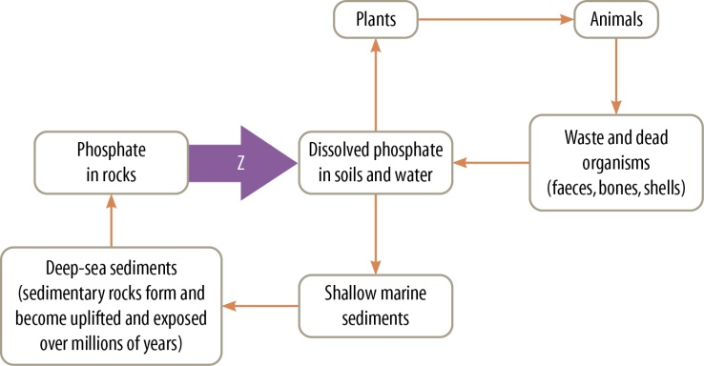  Identify the process occurring at Z.  - Weathering and erosion  - Evaporation  - Precipitation  - Oxidation |  | 1
 | Biosphere 2 and Earth are similar because they are both:  - artificial ecosystems.  - natural ecosystems.  - closed ecosystems.  - open ecosystems. |  | 1
 | The main difference between the greenhouse effect and enhanced greenhouse effect is:  - a decrease in greenhouse gases.  - the depletion of the ozone layer.  - an increase in carbon dioxide gas only.  - an increase in all greenhouse gases. |  | 1
 | The biosphere consists of components that interact to support life on Earth. These are:  - organisms, populations, communities and ecosystems.  - atmosphere, lithosphere, hydrosphere and biota.  - hydrosphere, lithosphere, biota and ecosystems.  - atmosphere, hydrosphere, biota and ecosystems. |  | 1
 | The main greenhouse gases are:  - methane, carbon dioxide, CFCs and nitrous oxide.  - carbon dioxide, nitrous oxide, sulfur dioxide and oxygen.  - water vapour, methane, sulfur dioxide and CFCs.  - methane, carbon dioxide, water vapour and nitrous oxide. |  | 1
 | The role of the ozone layer is to:  - trap greenhouse gases.  - trap UV radiation reradiated back into the atmosphere from the surface.  - block out 95% of the UV rays entering the atmosphere.  - react with CFCs to create more ozone. |  | 1
 | As energy flows through the environment, it cannot be lost or destroyed. Where does it eventually go? |  | 2
 | Fill in the gaps to write a chemical word equation that describes the process of aerobic respiration.  glucose + _____ → _____ + water |  | 2
 | Each of the water cycle processes in column 1 of the table below mainly takes place in one of the locations listed in column 2. However, the locations have been listed in the wrong order. Match each of the processes (a) to (e) with its correct location.  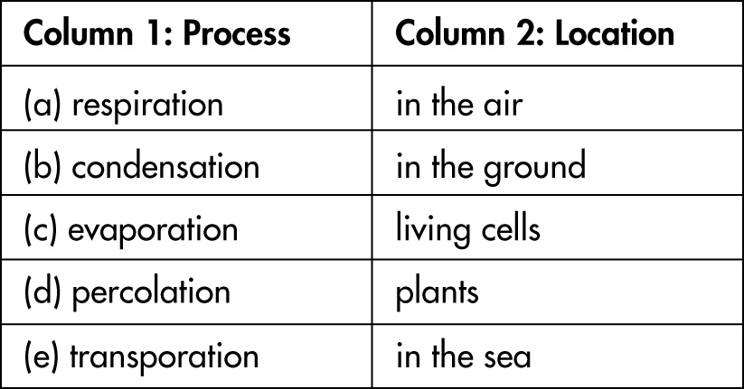 |  | 5
 | How is a sealed terrarium like the Earth? |  | 4
 | Why is ozone in the atmosphere important? |  | 2
 | What are the two main reasons that the balance of oxygen and carbon dioxide in the atmosphere is under threat? |  | 2

